Chapter 1 Problem 22 Michael Streyle

##   
## Call:  
## lm(formula = hardness ~ hours)  
##   
## Coefficients:  
## (Intercept) hours   
## 168.600 2.034

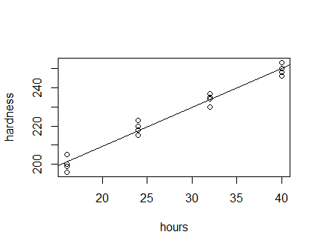

## (Intercept)   
## 249.975

## (Intercept)   
## 252.0094

## (Intercept)   
## 2.034375

The intercept is 168.6 Hardness units and the slope is 2.0344 hardness units per hour.